Content of Data Sheet
Product model | CAB-LC3100A-E-IN / CAB-LC3100B-E-IN
Product specification | HSYV-6 4×2×0.52 |  | 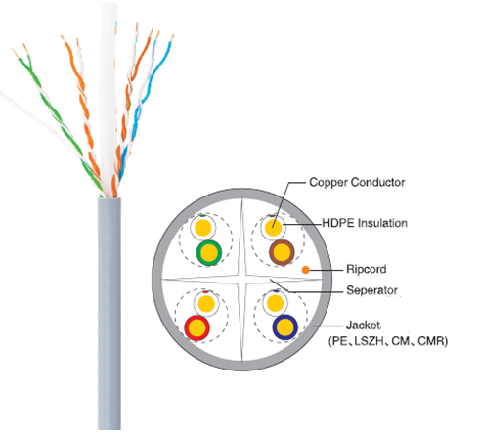
Test Standard | ISO/IEC11801、TIA-568-C.2
Conductor | Material | OFC(Oxygen free copper)
 | AWG | 24
 | Nom.O.D.(mm) | 0.52±0.03 mm
 | DC resistance | ≤95 Ω/km
Insulation | Material | HDPE
 | Thickness | 0.2±0.02 mm
 | Diameter | 0.93±0.05 mm
 | Color | Blue/White- Blue | Green/White-Green
 |  | Orange/White-Orange | Brown/White-Brown
Pitch | Offset pitch | ≤20 mm
 | Cable pitch | ≤120 mm
Sheath | Material | PVC(complies RoHS/REACH)
 | External O.D. | 5.8±0.3 mm
 | Color | Orange
 | Tensile strength | >13.5 Mpa
 | Thickness | 0.6±0.05 mm
Surface Printing | Letter height | 3.0±0.3 mm
 | Color | Black
 | Print error  & Space | 1±0.005 m
 | Case number | Yes
Packing | Packing | Carton
 | Once packing dimension | 420mm*205mm*420mm
 | Twice packing dimension | 450mm*440mm*445mm
 | Twice packing quantity | 2 cases
Packing length | 305±1m
Rip-cord | Yes |  | Crossing backbone | Yes
Ambient temperature | -20℃～60℃

